**Group Members**

**Group No - 05**

|  |  |  |
| --- | --- | --- |
| **PLYMOUTH ID** | **NAME** | **CONTRIBUTION** |
| **10673866** | R.G.M.N.S Rajapaksha | The solution,  Description,  Technical details,  Pros and cons,  Future enhancements and  Update,  Consultation,  Our decision – hybrid IaaS  Cloud development |
| **10673869** | T.S.S.C Silva | Off site development,  Cloud based development ,  Types of cloud  Development, log book and  Screen shots |
| **10679384** | B.D Geekiyanage | Introduction,  Cloud service and Development,  Traditional server development,  Virtualized Development ,  Onsite/ in house development |
| **10673973** | S.A.D.D.K Jayasinghe | Onsite technology , telecommunication room ,  command and control room an illustration of our solution |

**Contents**

* Group Members …………………………………………………………………………………………………..02
* Contents ………………………………………………………………………………………………………………03

❖ Introduction …………………………………………………………………………………………………………05

* Cloud Service & Deployment ………………………………………………………………………………..05
* Traditional Server Deployment …………………………………………………………………………….06
* Virtualized deployment ………………………………………………………………………………………..10
* Cloud based deployment ………………………………………………………………………………………12
* Public cloud …………………………………………………………………………………………………………13

❖ Private cloud ………………………….………………………………………………………………………………13

* Hybrid Cloud …………………………………………………………………………………………………........13
* Community cloud ………………………………………………………………………………………………….14
* Our Decision – Hybrid IaaS Cloud Deployment .…………………………………………………….16
* Onsite Technologies ……………………………………………………………………………………………..17
  + Telecommunication room Components …………………………………………………….17
  + Command and Control Center Components ………………………………………………18
  + Sales Showroom Components ……………………………………………………………….....19
  + Regional Storage Center Components ……………………………………………………….19
* An Illustration of Our Solution ………………………………………………………………………………20
* The Solution …………………………………………………………………………………………………………21
  + In the Sales Showroom …………………………………………………………………………….. 21
  + In The Cloud (Sales Showroom) ………………………………………………………………… 21
  + In The Regional Storage Center ………………………………………………………………….21
  + In The Cloud (Regional Storage Center) ……………………………………………………..21
* Firewall …………………………………………………………………………………………………………………22
* Technical Details ……………………………………………………………………………………………………23
  + Server Spec and Technical Details ………………………………………………………………23
  + Routers Technical Details …………………………………………………………………………..24
  + Firewall Technical Details …………………………………………………………………………..25
* Pros and Cons ……………………………………………………………………………………………………….27
* Future Enhancement and Upgrades ……………………………………………………………………..28
* Conclusion …………………………………………………………………………………………………………….28
* Meeting Minutes ……………………………………………………………………………………….28
* Turnitin report ………………………..……………………………………………………………………………. 34

# Introduction

In this detailed report our focus about the IT infrastructure deployment. There are different methods like Traditional server deployment, Virtualized server deployment method, cloud deployment method and housed or offsite methods.

By doing comparison we are going to determine the best case scenario (infrastructure) to the proposed system.

# Cloud Service & Deployment

* What is the Cloud Service?

A cloud service is any service made available to users on demand via the Internet from a cloud computing provider's servers as opposed to being provided from a company's own on-premises servers. Cloud services are designed to provide easy, scalable access to applications, resources and services, and are fully managed by a cloud services provider.

* What is cloud deployment?

There are four cloud deployment models: public, private, community, and hybrid. Each deployment model is defined according to where the infrastructure for the environment is located. There are three main cloud service models SaaS (software as a service), PaaS (platform as a service) or IaaS (infrastructure as a service) solutions that may be accessed on demand by end users or consumers. A cloud deployment model refers to the type of cloud computing architecture a cloud solution will be implemented on. Cloud deployment includes all of the required installation and configuration steps that must be implemented before user provisioning can occur.

* Main Cloud Service Models

1. SaaS –: Software as a service (SaaS) is a software distribution model

➢ Examples - BigCommerce, Google Apps, Salesforce, Dropbox,

2. PaaS -: Platform as a service (PaaS) is a cloud computing

➢ Examples - Apache Stratos, Amazon Web Services Elastic Beanstalk,

3. IaaS -: Infrastructure as a service (IaaS)

➢ Examples - DigitalOcean, Linode, Rackspace, Amazon Web Services

## Traditional Server Deployment

### Key Components of server Room

**• Physical Infrastructure**

Server is a hardware device or a software which accepts and respond the request which came by the network. A traditional server is a in-house server. All the hardware parts are gathered inside one place. It is very hard to configure because all the things are hardware components. When the server needs extend we have to purchase hardware equipment’s for that. This server is the most secured server as no one can enter to the server. The most important thing is this server need to monitor regularly as well as to handle this server there should be technical knowledge. According to this scenario to develop a sever room we should gather some materials referring to the respected ways. For that we have to investigate items in a proper manner. We use materials to design the server room. There are some ratings for the materials when designing data server. They are V-0, V-1, and V-2 ratings, and its shrinkage is effectively the same as PCABS, so it can be used in most cases with PCABS tools. To obtain the desired stiffness and other mechanical properties, the ratio of natural fiber to polypropylene to flame retardant may be varied.

Servers are categorized according to the way the servers are placed. There are 3 types as,

1. Tower Server
2. Rack Server
3. Blade Server

Tower Servers

This server is the basic type of the server and this need a large amount of space and also it looks like a desktop computer. This server is usually store in a cabinet. The good side of this server is that this server is cost effective as this this is the cheapest server from all the other servers, this server can be customize as well as upgraded based on the necessity and also as the density of the overall components is low this server cools down very easily. This is server is used in small business which have small number of clients. The main difficulty is that the cable management is very complicated. Rack Server This server are smaller than tower servers. These rack servers are measured by rack units or “U’s”. One of this U is around 19” wide and 1.75” tall. The most important facts are that in a one rack it contains many amount of additional devises as well as servers and also it is very easy to identify malfunctioning server and remove it and replace with another server. This is a cost effective server as it is relatively cost low. The power usage is high in this server as it has additional cooling system to cool down the server and also the maintenance is very hard as the number of racks get increase. The memory usage is high in this server.

Blade server is the latest server and also advanced server. The space usage is low in this server. And also the memory usage is lower than the rack server. This server is also known as hybrid server. This servers are placed inside blade enclosures, forming a blade system. This server connect all the blades by a single interface and because of that the maintenance and monitoring is easy. This server is very easy to handle and manage and also heavy effort is needed for the initial configuration. Most important thing is that this server need a special attention as it has to be supplied with ventilation, heating, and air conditioning system to ensure that the server doesn’t get overheated.

### Arrangements of server racks

Each device in the server rack will have its own SKU model and serial number. A data warehouse is a form of database or a way to use a database to store vast volumes of data. For the warehousing purpose we need to consider about cabling. We have to give attention to the Server layout equipment location, cabling distribution, cooling, patch panel.

According to the above details, we selected rack server for the scenario. Because of the memory management is easy and also the space management is easy. Also there are many memory slots and this rack server can use for centralized management systems. They are open frame server racks and enclosed racks. Open frame server rack is a perfect way to maximize cooling and make wiring simpler. These rack sizes vary from up to 58U and are fast and simple to install.

### Computing hardware

**Data storage**

Hard drives are planted in the front end of the server. For this server we have to use SSD Hard drives and we prefer to use raid 5 or 6 technology because it has the functionality to get the data if a drive or 2 drives get destroyed. Raid 5 is effective when we compare it to raid 10 by hard disk usage. Using internal storage system is effective when it comes to speed and data security. Third party can’t access the data. But we need to have an offsite backup. Cost is higher than cloud storing.

**Processors**

Processors are much more important for high performance business. It’s the head of the server. All the processing power depend on this main processor. We need a CISC processor with multiple core and which had good clock rate. we prefer choosing an Intel processor (Xeon brand).

### Power Distribution and Supply

Power is the backbone of a data center. Energy is used in the server room for computing hardware, HVAC, ventilation, health, and fire prevention. Most of the electricity is used by computing equipment and cooling devices. Power interruption, surge, sag, swell, line noise are major issues related to power. To overcome those issues, we use AVR, UPS, Inverter systems, and Surge Suppressers. AVR (Automatic Voltage regulator) takes out high voltage low voltage parts from the main current. It does not provide an effective solution for a power outage.

UPS (uninterruptible power supply) is the main solution for power outages. Providing adequate power solutions continuously is the main purpose of the UPS. ABB, Delta Power Solutions, Eaton are three of the most effective UPS structures for data centers. High operating costs, scalability problems, disastrous effects due to overload, are some of the concerns with the UPS framework. **Cabling system**

Cabling system is one of the most important system in the server because all the data is go through these cables. There are standards to follow when we do the cabling for protecting the system by over lapping, damaging, keeping maintain facility. TIA and EIA are the widely used cabling standards. When it come to a physical server, there are thousands of cables and it’s hard to maintain. When we design the room, we have to think about the cabling system too. Even when we place the racks we should keep the space for cabling as an example we should keep the space between rack and ceiling for some cabling options.

### • Cooling System

The key aim of the cooling system is to absorb heat and also it controls the pressure and humidity. It should run continuously. We need to implement the cooling system in a two way. If one system down, other system should run. underground cooling system is better option for servers.

### • Fire suppression and protection

A computer center holds a lot of useful info. The data server will also be safe from burning. Fire identification, warning, and automated activation are the key components of fire safety.

### • Physical Security and access control

We are going to install CCTV cameras, face detectors, sensors for security purposes to secure our data center.

## Virtualized deployment

Virtualization means to build a virtual version of device, servers, resource, storage or network. Virtualization help in many positive ways to the today world by reducing hardware cost, maintaining cost, and giving better implementation options, scalability, recovery. We can split physical resource and do multiple workload for maximum efficiency. There are 3 methods of virtualizing a system.

1. Full virtualization
2. Para virtualization
3. OS level virtualization

The right virtualization provider will help direct you through the understanding phase of the data, software, and processes are most important to the operations and health of your company. Some applications can need more dedicated server resources because of a reduced performance risk tolerance. In other instances, you might be sacrificing efficiency and pace for cost savings when it comes to seldom used assets

Because the virtualization servers are located offsite, you have an immediate disaster recovery advantage. Suppliers with effective risk-mitigation plans will in many cases greatly enhance the business continuity plans. Consider the ability of the company to accept loss of assets or computer down time when making a decision.

In the end, prevention depends on configuring the dedicated or virtual servers. If the workload of your entire company is placed on a single piece of equipment located in-house or in the virtual world of a vendor, failure may be devastating.

In certain cases, businesses can significantly reduce risk by moving to virtualization providers that provide sufficient security against both on- and off-site system failures and backups.

Your physical or virtual server security is dependent on configuration, staff expertise, and environment. Such factors, including risk reduction, can differ greatly depending on the particular requirements and internal resources of a company. Switching to virtualization may give improvements in security defense for many organizations with limited budget or hardware.

Data assets of many organizations are rapidly fast, which may raise problems related to room for IT teams. If you run out of space to properly store and maintain temperature control over your servers, it's probably time to explore physical server colocation or virtualization. As the data assets rising, it can become more difficult to maintain the correct temperature and humidity.

Over time, many organizations owners plan to gradually move their workloads to virtualization. If this is your goal, speak with your vendor about their current migration tools and have a conversation on compliance with the program.

Don't let the decision to go primarily virtual stand in the way of fear of complex immigration. Most companies find that transitioning to virtualization is much simpler than they expect, particularly though done slowly over time. But there are these disadvantages of the Virtualization system

### cons

Potential for low monthly recurrent payments, as opposed to higher initial spending.

Possible compatibility issues which are best discussed with a knowledgeable vendor.

Not all sellers are capable of bringing up or down the arrangement in tiny steps, and is primarily based on retailer practices.

You are no longer in charge of the physical server and the programs operating on them separately. Less speed

### pros

Less operating costs, as you don't need to buy hardware.

Configuration and repair capacity for reduced life cycle costs.

Links to professional assistance on licenses to install, customize, manage, and applications.

Reduced demand for The expertise inside the organization.

Possibility to simplify the servers and increase the productivity of the workload.

Lifespan is much longer than physic server

## Cloud based deployment

A cloud server is a virtual machine, operating in a cloud computing environment. It is designed, stored, and distributed over the internet through a cloud computing platform and is accessible remotely. Often, they are known as virtual servers. Cloud servers have all the applications they need to run, so they will function as independent units.

A cloud storage offers reliability and protection for the business user as any technical bugs are removed from the system. Many cloud services do not affect the cloud server Like physical servers, if another person overloads their cloud server, it would have little effect on the cloud server.

Safe, fast, and stable cloud servers.

They escape the hardware issues found with physical servers and are likely to be the most reliable choice for businesses looking to hold down their IT budget.

Cloud servers are delivering a quicker service to your capital. You can get more staff and a database quicker than you can at a real server price close to that. A website that is stored in the cloud will run quicker.

With cloud computing, you get the scalability. Upgrading by adding memory and disk space, and being more accessible, is very simple and fast.

There are 3 type of cloud service

### Public cloud

The most popular way to implement cloud computing is via public cloud.

The computing services re-owned and managed by a cloud service provider from third parties and distributed over the Internet.

With a public cloud, the cloud provider owns and manages all of the hardware, software, and other support infrastructure. In a shared cloud, you share with other company’s same hardware, software, and network equipment.

You access resources and manage your account through a web browser. Public cloud services are also used to offer Web-based messaging, remote office software, storage, and environments for testing and development.

•  **Advantages of public clouds:**

Lower costs—you don’t need to purchase hardware and software, and you pay only for the service you use.

No maintenance—your service provider provides all the the maintenance. Near-unlimited scalability—you can expand your resource at any given time High reliability—a vast network of servers ensures against failure.

### Private cloud

A private cloud is computing services which are used solely by one entity. The private cloud can either be physically installed at the datacenter of the company, or it can be managed by a third party service provider. But the systems and resources are still stored in a private domain, and the hardware and software is dedicated entirely to the enterprise. A private cloud can therefore promote an organization's ability to tailor its services to meet unique IT needs. Private clouds are frequently used by any other mid- to large-sized organizations with business-critical operations seeking increased control over their environment.

• **Advantages of a private cloud** flexibility—your organization can change its cloud environment to complete and success and specific business needs.

Security—resources are not shared with others, so higher levels of control and security are possible.

Scalability—private clouds still afford the scalability and efficiency of a public cloud.

### Hybrid Cloud

Hybrid clouds integrate on-site or private cloud services with public clouds to allow companies to enjoy the advantages of both. Data and programs in a hybrid cloud will switch between private and public cloud for better flexibility and further delivery options. Of example, of high-volume, lower-security needs such as web-based email, and private cloud, you can use the public cloud for confidential, business-critical operations such as financial reporting. Where the company will "burst" into the public cloud to access external computing tools

* **Advantages of Hybrid cloud**

Control — your organization can keep a sensitive asset private infrastructure.

Flexibility — you can leverage additional public cloud resources when you need them.

Cost-effectiveness — you only pay for additional computing power as needed, and the option to scale up to the public cloud.

Ease — transition to the cloud doesn't have to be stressful, as you can slowly migrate — phasing over time in workloads.

* **Advantage of cloud server**

No on-site equipment or operating costs needed. Well-suited for smaller companies that could outgrow infrastructure so quickly.

Storage can be added if necessary. Many ideas are on sale and you pay more for what you need. You can start backup and restore from anywhere, using any device, laptop, or smartphone.

Data can be backed up to 15-minute increments in the cloud as well, reducing data loses in emergency scenarios. Limited recovery time set for the data is increased.

Disadvantage of cloud server

The data recovery costs could outweigh the advantages for companies who are not as dependent on instant recovery.

Organization can have a data limit that may be saved in the cloud due to the capacity and cost of storage.

If the Internet goes down on your side or on the side of your cloud provider, you won't have access to all of your records.

If we use Datto like service, recovery will take place in minutes.

So according to our company we have to deal with customers who use online system and traditional system. When it comes to traditional customers, it is a wastage to Maintain a cloud base database for them. But there are online customers and we have to use online system for them and Cloud will probably help to maintain the business for them. There are lot of points to compare as well as we mentioned the above topic. So We can solve lot problems by bringing a Hybrid Server system. Choosing an in-house, cloud or hybrid solution is largely dependent on the operations, goals and capabilities of your business.

Even if we find out that virtualized server is less expensive than cloud server, there are few cons we can see when comparing both servers

If They don't provide higher availability. The virtual server fails if the actual server fails.

Security issues may be raised. If a customer on your mutual server fails to take protection seriously and gets compromised or gets a virus, your VPS may be affected adversely.

Computing resources are shared between all clients and RAM, bandwidth and CPU capacity can be impaired if a higher load is requested by another VPS on the same server.

They're just not flexible. Space is based on the limits of physical servers. Once you have exceeded your max VPS ability, you either need to purchase more room or look at other options. The move to a new approach could take several hours or days of downtime.

### Community cloud

A community cloud service model is a platform that allows limited number of individuals or organization which are manged by a third party service provider or managed commonly by all related organizations to use a cloud computing solution.

Community clouds are a type of privet cloud which is built specifically for a target group. the communities using a specific community cloud have similar cloud requirements and their goal is to work together to achive their business objectives.

Community clouds provides a central cloud computing facility for the organizations working on joint projects , applications and research activities which allows them to create , manage and execute those projects even if they are using different types of solutions.

Advantages are;

* If is flexible and expansible
* Can be used at any time and reliable
* Improved services

## Our Decision – Hybrid IaaS Cloud Deployment

* What exactly is a Hybrid Cloud?

It is a cloud computing environment that operates on a combination of services of both private cloud and public cloud with the process of orchestration. It helps in moving the data from private to public or vice versa as per the requirements in terms of cost, time and demand. The biggest advantage is “Flexibility in data handling and proper deployment of data” in the business and workflow processes towards dealing with data. In the hybrid cloud, the setup requires compatibility between private and public cloud. It is a way towards achieving agile solutions.

* How Hybrid Cloud is different from Public and Private Cloud?

have direct control over Public cloud is basically managed by a third party or a vendor company, which takes a stipulated subscription fee or charges, and in turn, provides the entire cloud infrastructure and complete resources to their clients. Payment is made to the vendors for only those services, which are being used by the company. It provides reliability, cost benefits, and expertise.

Whereas in a private cloud, the cloud platform/server is managed within the company’s own data center. Hence, The companies the cloud infrastructure.

### • Advantages of using hybrid cloud technology

1. It provides Agility to business. Agility is the ability to perform quickly and easily.
2. Provides more flexibility to businesses, rather than solely relying on either private or the public cloud.
3. It is very much suggested in “dynamic environment”, considering its advantages and characteristics.
4. It helps in managing both capital expenditure as well as operating expenditure.
5. Enjoys the benefit of both platforms, public and private.
6. It has successfully tackled the barriers to information too, which existed in traditional IT infrastructure, now businesses can effectively respond to rapidly changing market situations.

### • Why IaaS Service Model

Cloud infrastructure services also known as Infrastructure as a Service (IaaS), are made of flexible and automated compute resources.to access and monitor computers, networking starting and for other services Iaas is fully self serviced. It allows businesses to purchase resources based on the demand and as per required so that there is no need of purchasing all the hardware

By using virtualization technology iaas provide cloud computing with servers networking , operating system networking these cloud servers are provided to the organization using a dashboard or API . this gives the total control of the same system to the iaas client. The same technologies and capabilittes of a traditional data center is provided by iaas. The only difference here is that there is no need of maintain or managing is physically iaas clients it physically iaas clients has the ability of accessing their servers and storage directly , but it is our soured by a virtual data center in the cloud .

The are certain situation when ‘Iaas’ is useful live in Saas and Paas . For small companies and start up it is advisable to use iaas so that it will not cost much to purchase hardware and software but for larger companies , they need to hold onto the complete control over their system. they should only purchase what they need. Companies which are growing rapidly just like how iaas expounds , can change hardware and software according to their need whenever there is a new requirement if there is a new application’s demand. Iaas provides many flexible and vast number of choices to suit your need.

### • IaaS Advantages

1. One of the most used clod computing model
2. Easy to use automatically without any man power of storage, networking, servers, and processing power
3. Hardware can be purchases and customized to suit your needs.
4. Resources are easy to find.

### • IaaS Characteristics

1. Resources are available as a service
2. Cost varies depending on consumption
3. Services are highly scalable
4. Multiple users on a single piece of hardware
5. Organization retain complete control of the infrastructure 6) Dynamic and flexible

## Onsite Technologies

### • Telecommunication room Components

* phone systems;
* power protection;
* LAN equipment;
* main distribution frame;
* uninterruptable power supplies;
* data processing equipment.
* file servers;

### • Command and Control Center Components

* GPS Monitoring System
* Phone System
* LAN Equipment
* CCTV Monitoring System
* Server Management System
* Typical internet Connection

### • Sales Showroom Components

* CCTV System
* AI Base Image Recognition Retail System
* Phone System
* Lan Equipment
* Digitize Showroom Audit System

### • Regional Storage Center Components

* CCTV System
* AI Base Image Recognition Store Management System
* Phone System
* LAN Equipment
* Digitize Store Audit System

### An Illustration of Our Solution

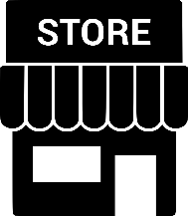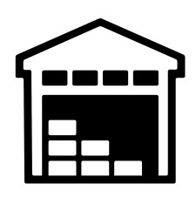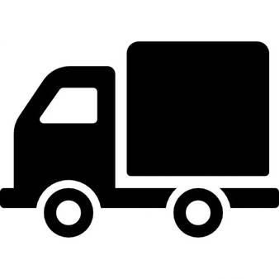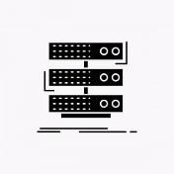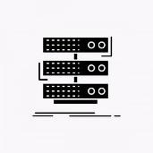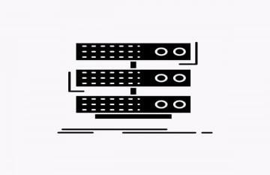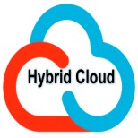

### The Solution

#### • In the Sales Showroom

1. The CCTV Camera system is installed so that every rack in the mall can be imaged properly
2. It shoots all the shelves every thirty seconds.
3. The images are immediately uploaded to the cloud
4. After the shop closed. A record of the released bills will also be uploaded to the cloud.

#### • In The Cloud (Sales Showroom)

1. Uploaded images are analyzed by AI Based Image Recognition Software
2. After the analysis, it makes a report of items sold that day
3. It compares with the report uploaded by the store that day
4. If Any changes in the two records will be reported to the Command and Control Center
5. An overview of finished goods in the shop, and an application to refill those items.

will be directed to the regional storage center

1. Also all Report copies are sent to the Command and Control Center

#### • In The Regional Storage Center

I. Same as Sales Show room CCTV Camera Installed in Regional Storage Center II. It Shoots all area of Storage in every thirty second

1. The images are immediately uploaded to the cloud Same as Sales Showroom
2. A record of both inbound and outbound stocks is uploaded to the cloud every 24 hours

#### • In The Cloud (Regional Storage Center)

1. Uploaded Images Are Analyzed by Ai Base Image Recognition Software Same as Sales showroom
2. After The Analysis, it makes a report of inbound and outbound stock in that day
3. It compares with the report uploaded by the regional storage that day
4. If any changes in the two records will be reported to the Command and Control Center

#### **Firewall**

* Why need firewall

A firewall is a network security device that monitors incoming and outgoing network traffic and permits or blocks data packets based on a set of security rules. Its purpose is to establish a barrier between your internal network and incoming traffic from external sources (such as the internet) in order to block malicious traffic like viruses and hackers.

* Advantages of Firewall for Server and cloud Computing

* + Traffic Monitoring
  + Trojans blocking
  + Stopping Hackers
  + Stop Key loggers

* Disadvantages of Firewall for Server and Cloud Computing

* + Cannot block inside attacks
  + Higher cost
  + Difficult to installing
  + Complex Operations

**Technical Details**

### • Server Spec and Technical Details

Dell EMC Power Edge MX840C

* Processor – intel Xeon Second gen CPU
* RAM - DDR4 RDIMMs 1TB Memory
* Controllers- Internal controllers: S140 Software RAID, HBA330 Internal SAS HBA,

PERC H730P Adapter,

PERC H745P Adapter, HBA330 mini-mezzanine SAS HBA

Internal boot options: Choice of optional Boot Optimized Storage Solution (BOSS) (2

X M.2 SDDs) or

Internal Dual SD Module (IDSDM)

* Drive Bays- 1TB NVMe SSD+4TB Six HDD
* Power Supply-3000w
* 6fan cooling
* Dimension- 610.39mm (24.03 inches) x 250.2mm (9.8 inches) x 85.5mm (3.37 inches)
* Open Manage™ SW- Open Manage Enterprise
* Integrations & Connections- Microsoft® System Center
* Security- TPM 1.2/2.0 (optional)

Cryptographically signed firmware

Silicon Root of Trust

* OS- Microsoft Windows Server® with Hyper

•

CCTV System Technical Details

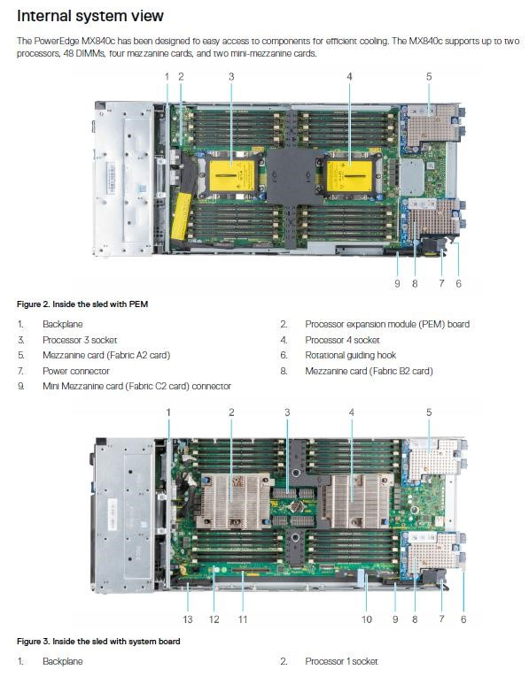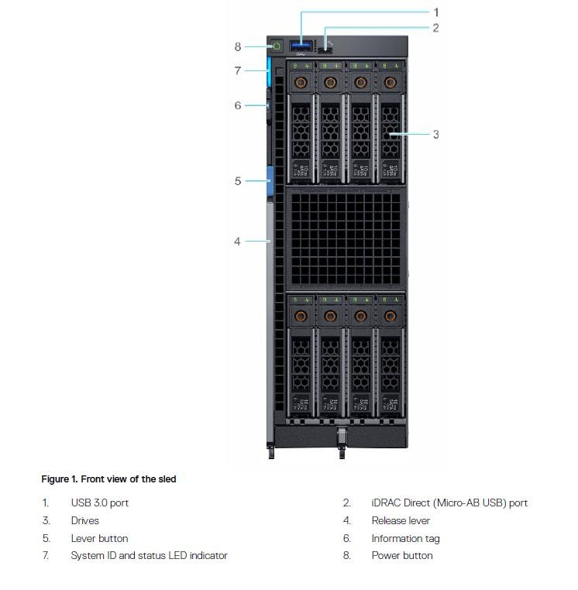

#### • Routers Technical Details

Cisco ASR 1001-HX Router

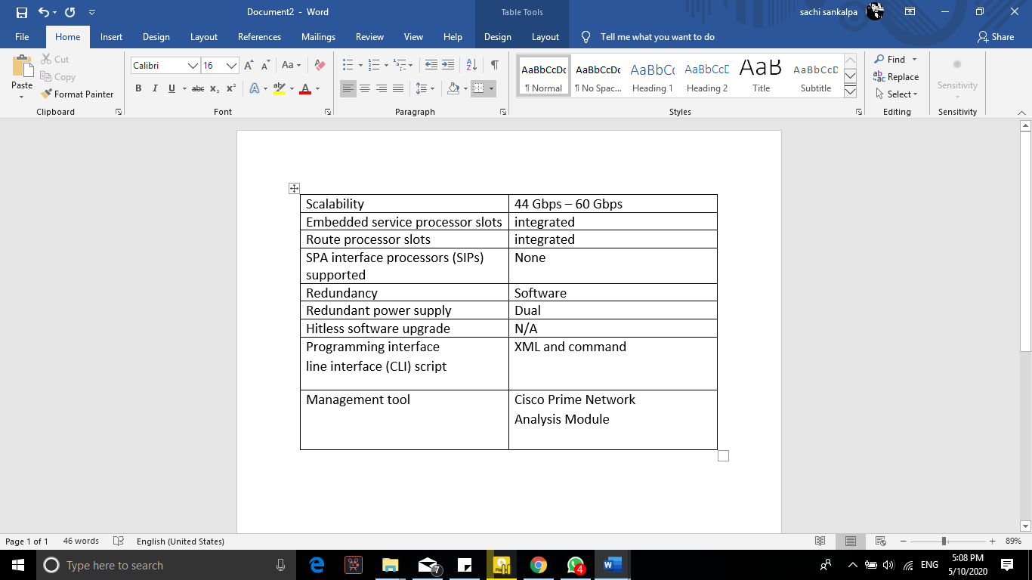

#### • Firewall Technical Details

Cisco ASA 5500-X with Firepower Services

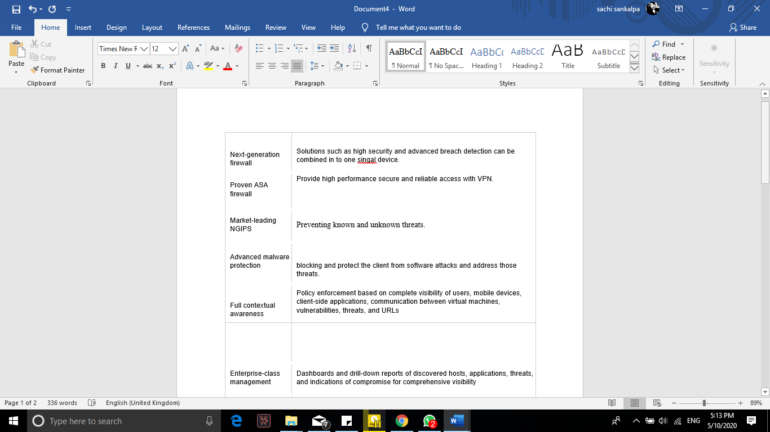

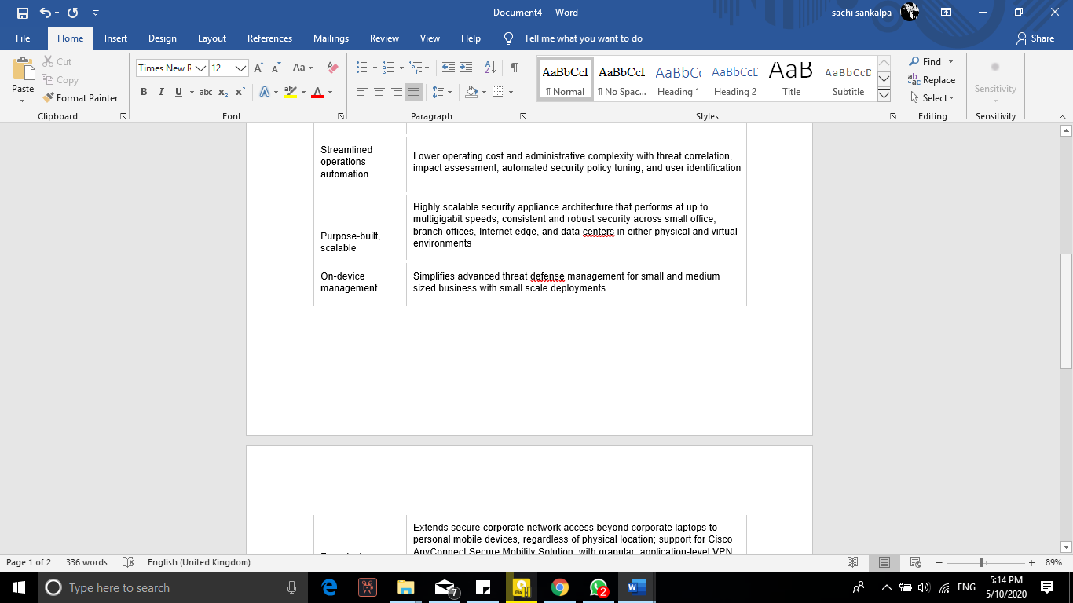

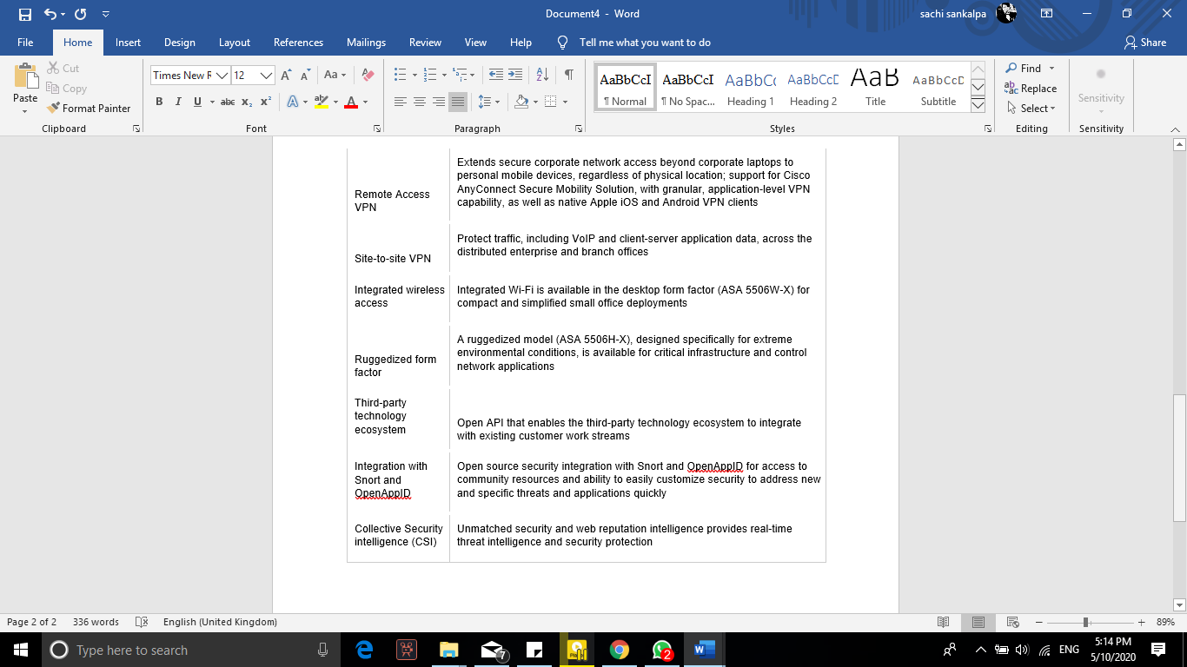

#### Pros and Cons

**Pros Cons**

|  |  |
| --- | --- |
| Reduced Human resources | Distracting to the core business |
| Store visiting & auditing Can Be reduce | Very capital intensive |
| Very Easy To analyze business Details | Lack of Cost Transparency |
| Higher Productivity | Complexity |
| Security issues Are Reduced | Limited geographic expansion abilities |
| Higher Customer Satisfaction | Higher Initial Cost |
| Very Easy to Mange Storage And Showroom | More limited connectivity options |
| Greater Flexibility | Too difficult to install |
| Pay Per Use | Tendency to run lower-tier facilities |
| Better business continuity and disaster Recovery | Tendency to choose locations away from premium areas and network hubs |
| High degree of control over facilities |  |
|  |  |

### Future Enhancement and Upgrades

* Server storage capacity must be increased
* Server ram capacity increasing for better performance
* Cloud storage capacity increasing
* Network speed Upgrade
* Image recognition System Developing for human productivity monitoring
* Software Errors and fault Reducing
* Security Improving (Firewall upgrading)
* CCTV Camera improving for Take a Better Images
* Improve retailing base on AI and customer reviewing
* Built app for Convenience to customer reviewing and online purchasing  Improve AI with big data

#### Conclusion

Cloud computing is the next step of business. Using cloud computing we can get lot of benefits

But in installing procedure it can be a challenge. and in installing procedure cause loss data And lower retailing. difficult to run business in installing time because during CCTV Installation must be damage to customer Satisfaction but after these challenges all things on business are easier. But this system cannot protect from inside attacks some risks can manage by using stronger password but find trustful Contractors must be challenge.

**Key point of after system installing**

* Customer can find item through smart phone app
* Easy to analyze stock
* Easy to analyses productivity
* Easy to analyze most selling products
* Improved security (CCTV)
* reduce human resources

**Estimate quotation**

Approximately between three to six million Rupees

**PART B**

**Virtualization Platforms**

* Types of Virtualization Platforms (Most Common)
* Application Virtualization
* Desktop Virtualization
* Hardware Virtualization
* Network Virtualization
* Storage Virtualization
* Application Virtualization

Application virtualization is a product innovation that embodies PC programs from the fundamental working framework on which they are executed. A completely virtualized application isn't introduced in the conventional sense, [1] in spite of the fact that it is as yet executed as though it were. The application acts at runtime like it is straightforwardly interfacing with the first working framework and all the assets oversaw by it, however can be disconnected or sandboxed to fluctuating degrees.

* **Pros**
* No Install Required
* Fix application conflicts
* No registry and system bloat
* Multiple runtime environment
* Easier update management
* Versioning
* Improved Security
* Easy to customize application

* **Cons**
* Bandwidth requirements
* I/O requirements
* More infrastructure
* Higher cost
* Device driver, boot service, com+, antivirus and firewall, VPN clients These application cannot be virtualized in application virtualization.
* Desktop Virtualization

Work area virtualization is a product innovation that isolates the work area condition and related application programming from the physical customer gadget that is utilized to get to it.

* **Pros**
* Security and Reliability.
* Access Anywhere.
* Uniformity and Control.
* Ability to Switch Environments on the Fly.
* **Cons**
* Usually requires network access
* Single Failure Point.
* Multiple Use Cases Require Multiple Images.
* Long-term ROI
* Hardware Virtualization

Equipment virtualization is the virtualization of PCs as complete equipment stages, certain intelligent deliberations of their componentry, or just the usefulness required to run different working frameworks. Virtualization shrouds the physical attributes of a registering stage from the clients, introducing rather a theoretical processing stage. At its beginnings, the product that controlled virtualization was known as a control program, yet the terms hypervisor or virtual machine screen got favoured after some time Pros.

* Lower Cost
* Efficient resource utilization
* Increase IT flexibility
* **Cons**
* Very high cost
* Limitation
* Availability issues
* Scalability issues
* Network Virtualization

In registering, organize virtualization or system virtualization is the way toward consolidating equipment and programming system assets and system usefulness into a solitary, programming based managerial substance, a virtual system. System virtualization includes stage virtualization, frequently joined with asset virtualization.

* **Pros**
* Reduced Hardware & Power Consumption
* Automated Management
* Improved Scalability
* **Cons**
* Security risk
* Higher Cost
* Storage Virtualization

A "storage system" is also known as a storage array, disk array, or filer. Storage systems typically use special hardware and software along with disk drives in order to provide very fast and reliable storage for computing and data processing. Storage systems are complex, and may be thought of as a special purpose computer designed to provide storage capacity along with advanced data protection features.

* **Pros**
* allows for migrations to be performed quickly
* creates better workflows.
* allows more than one type of storage array.
* cheaper option for storage.
* provides better access to your data.
* **Cons**
* requires to deal with multiple vendors**.**
* It can make upgrades challenging to process.
* does not always scale to some areas.
* not eliminate data security risks
* Server Virtualization

Server virtualization is a virtualization technique that involves partitioning a physical server into a number of small, virtual servers with the help of virtualization software. In server virtualization, each virtual server runs multiple operating system instances at the same time.

* **Pros**
* Reduced costs
* Easy Backup and recovery
* Many Operation Can Be Operated
* **Cons**
* High upfront costs
* Security faults
* Too difficult to learning

**Virtualization vendors**

* Best virtualization vendors
* VMware
* Xen
* KVM
* Hyper V
* VMware

VMware Workstation is a virtual machine programming that is utilized for x86 and x86-64 PCs to run different working frameworks over a solitary physical host PC. Each virtual machine can run a solitary occasion of any working framework (Microsoft, Linux, and so on.) at the same time. VMware Workstation firmly underpins equipment.

* **Pros**
* Rich features (vSphere HA , Vmotion , DRS)
* Very Large Eco System
* All OS Vendor Make it Supported And certified under ESXi
* **Cons**
* Per core license-expensive
* Proprietary platform
* Xen

Xen is a hypervisor that runs directly on the system hardware. Xen inserts a virtualization layer between the system hardware and the virtual machines, turning the system hardware into a pool of logical computing resources that Xen can dynamically allocate to any guest operating system.

* **Pros**
* Quick [prototyping
* Compatibility with emerging architecture
* **Cons**
* No optimization (Yet)
* KVM

Kernel-based Virtual Machine (KVM) is an open source virtualization technology built into Linux. Specifically, KVM lets you turn Linux into a hypervisor that allows a host machine to run multiple, isolated virtual environments called guests or virtual machines (VMs)

* **Pros**
* Native Performance
* Full Virtualization
* security and Failure Isolation
* Open Source and Support for New Platforms
* **Cons**
* Hyper V

Hyper-V is Microsoft's hardware virtualization product. It lets you create and run a software version of a computer, called a virtual machine. Each virtual machine acts like a complete computer, running an operating system and programs.

**Virtual machine**

In computing, a virtual machine (VM) is an emulation of a computer system. Virtual machines are based on computer architectures and provide functionality of a physical computer. Their implementations may involve specialized hardware, software, or a combination.

* Types of virtual machine

* System virtual machines
* Process virtual machines
* System virtual machines

In computing, a system virtual machine is a virtual machine that provides a complete system platform and supports the execution of a complete operating system.

* Process virtual machines

A Process virtual machine, sometimes called an application virtual machine, runs as a normal application inside a host OS and supports a single process. It is created when that process is started and destroyed when it exits. ... For example Wine software in Linux helps to run Windows application .

**Our Decision – Server Virtualization with VMware vSphere**

* Why Server Virtualization

* Server combination

By falling physical servers into virtual servers and diminishing the quantity of physical servers, your organization will harvest a gigantic investment funds in force and cooling costs. Furthermore, you'll have the option to decrease the datacenter impression which can incorporate diesel generator costs, UPS costs, organize switch costs, rack space and floor space.

* Stop server spread

Prior to server virtualization, administrators had to over-arrangement servers to guarantee that they would satisfy client need. With server virtualization, there is not any more over-provisioning and you'll have the option to splendidly measure each virtual machine.

* Do more with less

With a slacking economy, IT divisions and administrators are compelled to accomplish more with less. Server virtualization makes administrators progressively effective and nimble, permitting us to accomplish more with less and resemble the saints of the IT division.

* Cost reserve funds

Not exclusively will your organization save money on the physical server equipment, influence and cooling of the servers that were united, you'll additionally save money on the time it used to take to regulate physical servers. End clients will be increasingly profitable gratitude to less personal time and significantly more.

* Moving running virtual machines

Genuinely one of the more remarkable highlights of server virtualization is the capacity to move a running virtual machine starting with one host then onto the next with no personal time. VMware's vMotion can do this for you and that component makes different highlights like appropriated asset scheduler (DRS) and disseminated power the executives (DPM) conceivable.

* Increased uptime

Highlights like vMotion, stockpiling vMotion (svMotion), DRS, and VMware high accessibility (VMHA) all outcome in virtualized servers being ready for action far beyond those equivalent servers that were running straightforwardly on physical equipment.

* Image-based reinforcement and reestablish

By having the option to back up and reestablish whole virtual machines, you can substantially more rapidly back up the VMs and set them back, if necessary. Furthermore, picture level reinforcements make calamity recuperation so a lot simpler. Considerably increasingly, just changed squares should be supported up and reinforcements should be possible in the day on account of preview innovation.

* Virtual labs

By having the option to make a virtual lab (a gathering of VMs on a private virtual system), you can test vSphere, Exchange, Active Directory and significantly more. Already, this would have been cost restrictive with physical servers.

* Simplified fiasco recuperation

On account of virtual machines being equipment free (not attached to a specific physical server) you can re-establish picture put together reinforcements with respect to any equipment that is equipped for running vSphere. Furthermore, programming highlights like site recuperation director (SRM) computerize the testing and failover when a fiasco strikes.

* Allow us to move to the cloud

By virtualizing our servers and making them convenient, we are currently prepared to move them to a cloud facilitating organization when that innovation develops and when we feel great with it.

* Why VMware vSphere
* **Proven Technology**

The VMware was founded in 1998 and has survived the tides of changing technology ever since. However, that's not all; they also led the industry with the wonderful products they offer. No doubt, the VMware products present a full spectrum management system that's perfect for a Cloud virtual machine. Likewise, in today's world, these are perceived to be something of a gold standard, especially in the virtual machine tech sphere. Considering this, we could say that the VMware has an outstanding track record as it continues to be the leader in the field of virtualization, which could be of great help in a company as it tries to expand into the virtual realm.

* **High Availability**

Perhaps the best favourable position to the VMware vSphere framework is the high accessibility it offers. The high accessibility helps in dealing with the virtual machine's accessibility freely of both the equipment and programming layer. Likewise, in light of the fact that the VM can work even in complex procedures all the while, it has been considered as a significant component that could give a smooth activity to all the remote clients. This element likewise furnishes the organization's cloud machine with the sort of security it needs so as to keep away from both equipment and working framework disappointments.

* **Large Corporate User Base**

The VMware has been embraced by a few organizations around the world. This is a direct result of the predominant ease of use and demonstrated record of VMware offers. To help that, 100% of both Fortune Global 100 and Fortune 100 organizations are at present utilizing the VMware innovation in their IT framework. Beside that, most VMware clients report an amazing ROI inside the main year of utilization. This sort of reputation given by incredible organizations just demonstrates that a VMware facilitated condition could truly help in improving the organization's virtual machine benefit and reasonability.

* **Ability to Transfer Virtual Machine Images**

One of the benefits that you could appreciate with the VMware vSphere is that it's broadly open. This offers the clients the chance to fare and import their virtual machine's pictures that originated from the nearby condition. This gives the client the opportunity to move framework where they're most appropriate. Moreover, this is additionally an extraordinary method to forestall burning through your time as you attempt to set up programming and making arrangement changes inside the server, just to guarantee that it'll run easily.

**Future Enhancement Path**

* Upgrade to faster server processors increase speed.
* Upgrade memory capacity for better performance.
* Upgrade to faster and big storage for big data processing.
* Upgrade firewall for better protection.
* Network upgrade for better speed.

**Technical Details**

* Center Server and vSphere Client Minimum Hardware Requirements
* CPU

Two 64-bit CPUs or one 64-bit dual-core processor.

* Processor

2.0GHz or faster Intel 64 or AMD 64 processor. The Itanium (IA64) processor is not supported. Processor requirements might be higher if the database runs on the same machine.

* Memory

4GB RAM. Memory requirements might be higher if the database runs on the same machine

* Disk storage

4GB. Disk requirements might be higher if the vCenter Server database runs on the same machine. In vCenter Server 5.0, the default size for vCenter Server logs is 450MB larger than in vCenter Server 4.x. Make sure the disk space allotted to the log folder is sufficient for this increase.

* Microsoft SQL Server 2008 R2 Express disk

Up to 2GB free disk space to decompress the installation archive. Approximately 1.5GB of these files are deleted after the installation is complete.

* Networking

Gigabit connection recommended.

* Server Specifications

Dell EMC Power Edge MX840C

Processor – intel Xeon Second gen CPU

RAM - DDR4 RDIMMs 1TB Memory

Controllers- Internal controllers: S140 Software RAID, HBA330 Internal SAS HBA, PERC H730P Adapter,

PERC H745P Adapter, HBA330 mini-mezzanine SAS HBA

Internal boot options: Choice of optional Boot Optimized Storage Solution (BOSS) (2 X M.2 SDDs) or

Internal Dual SD Module (IDSDM)

Drive Bays- 1TB NVMe SSD+4TB Six HDD

Power Supply-3000w

6fan cooling

Dimension- 610.39mm (24.03 inches) x 250.2mm (9.8 inches) x 85.5mm (3.37 inches)

Open Manage™ SW- Open Manage Enterprise

Integrations & Connections- Microsoft® System Center

Security- TPM 1.2/2.0 (optional)

Cryptographically signed firmware

Silicon Root of Trust

OS- Microsoft Windows Server® with Hyper

**Meeting Minutes**

1. 24/03/2020 – First we made a WhatsApp group for this assignment. we basically talked the whole assignment with this group chat.

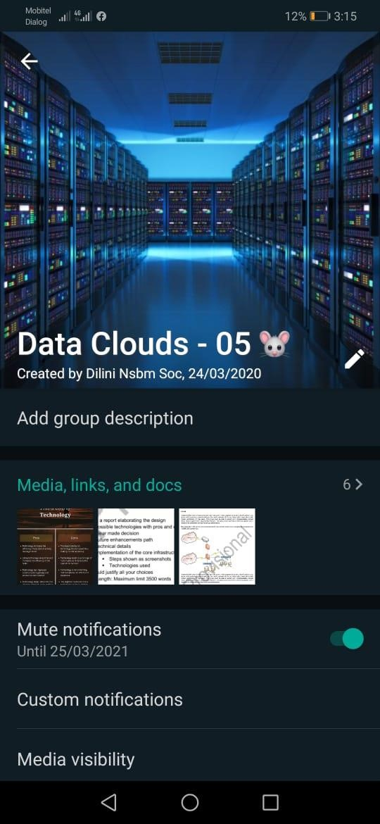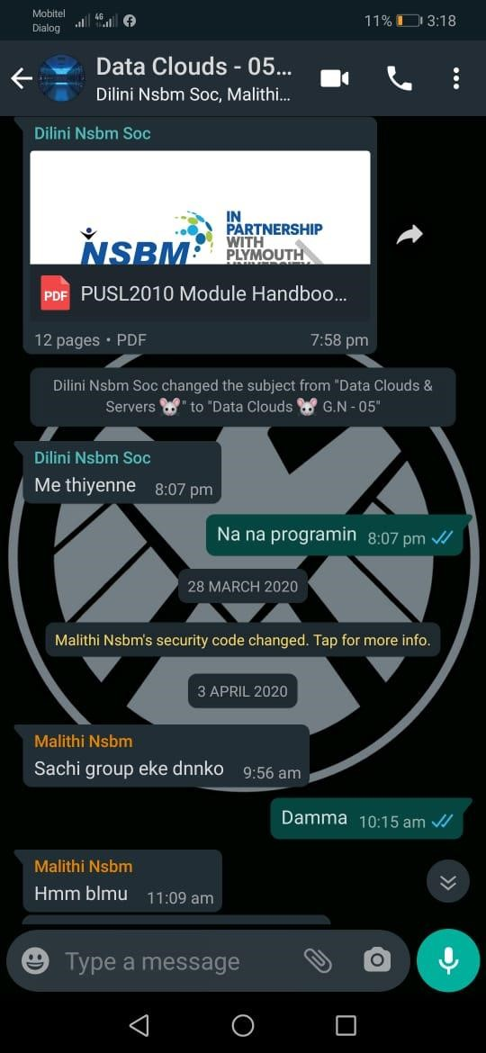

1. 06/04/2020 – Once we connected again with call the shares were shared. Then we started this.

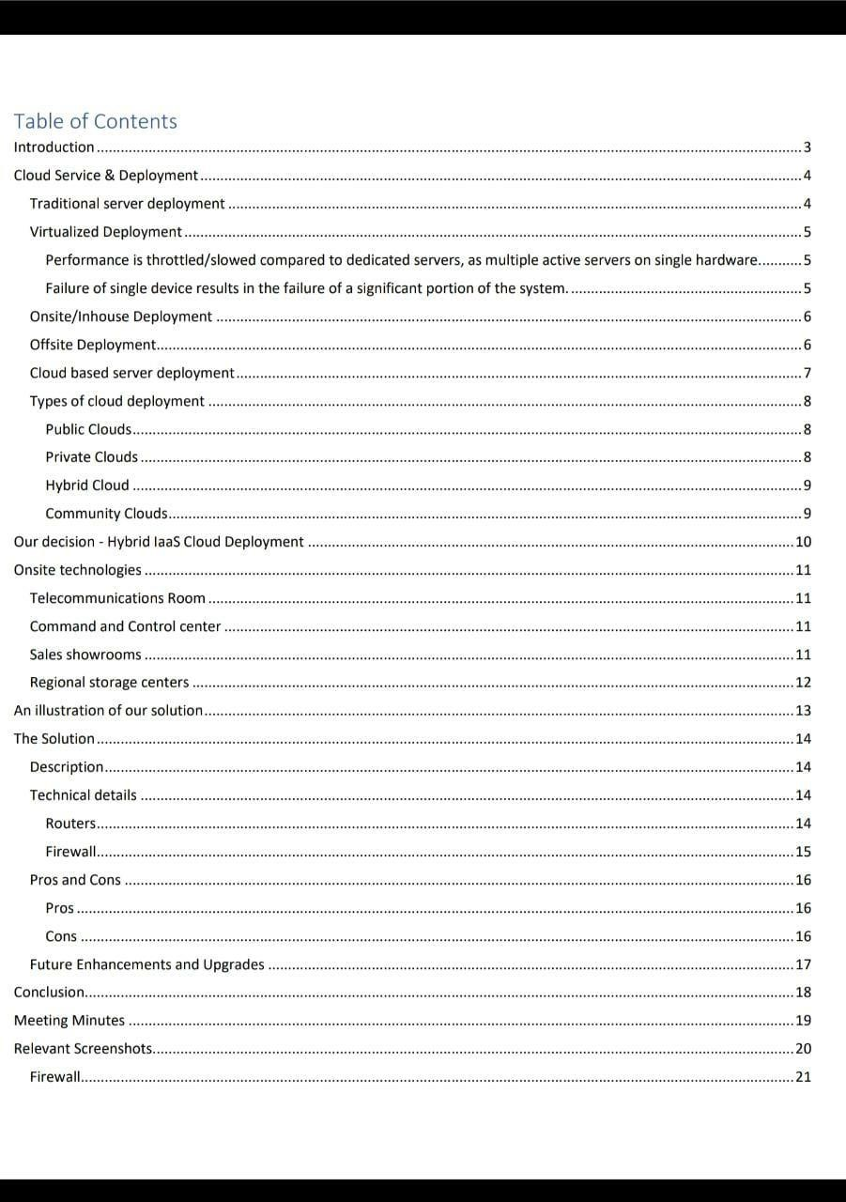

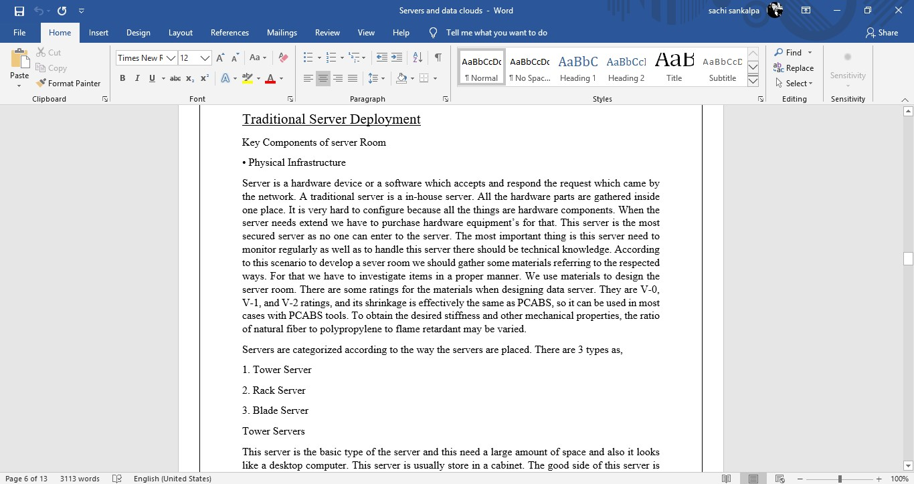

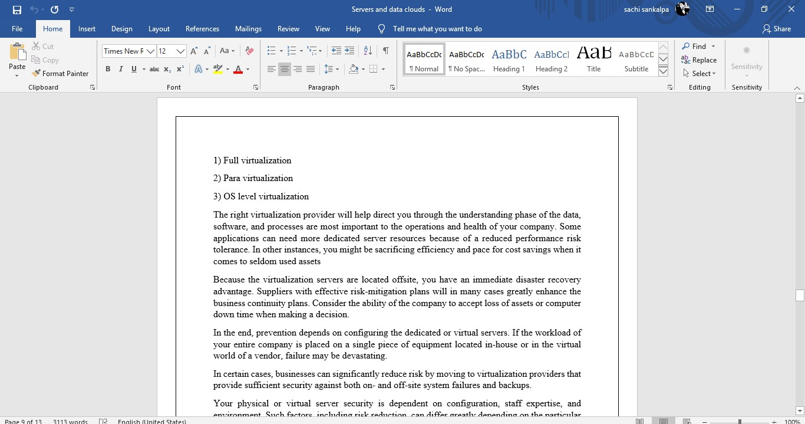

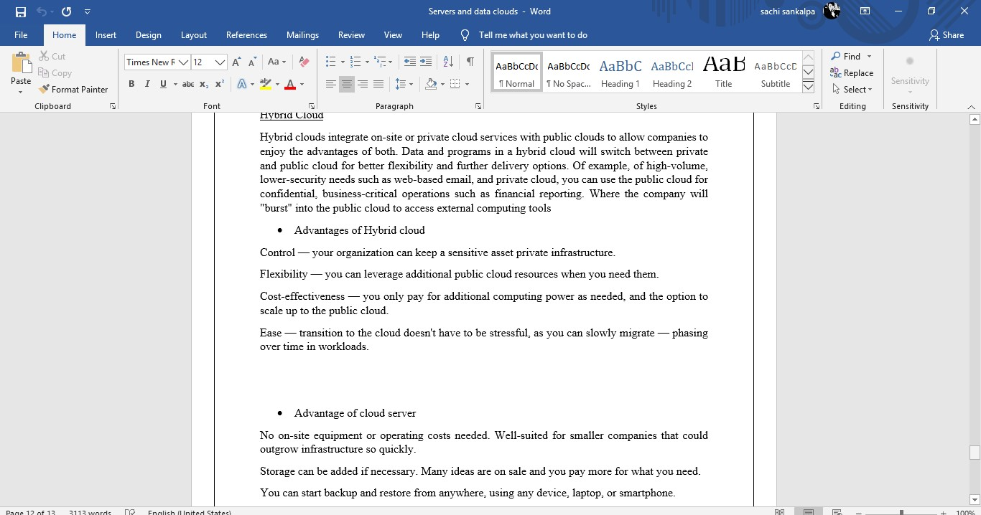

1. 15/04/2020 – we started to talk about the best solutions for the given scenario.

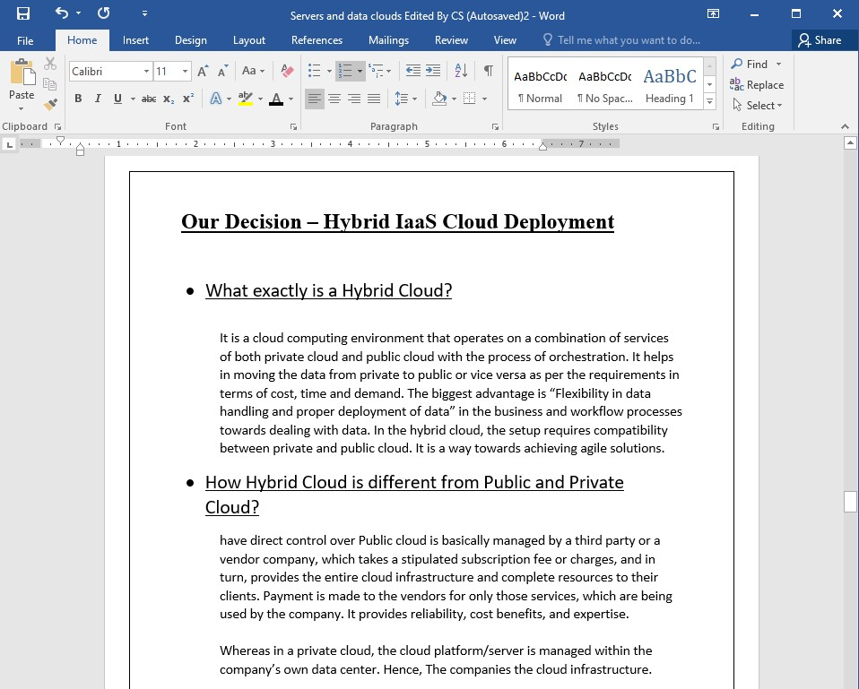

1. 20/ 04/2020 – we continued our chat about the selected solution and completed the repot. And we talked this technical details and daunt parts.



1. 23/04/2020 – then we complete our technical details.

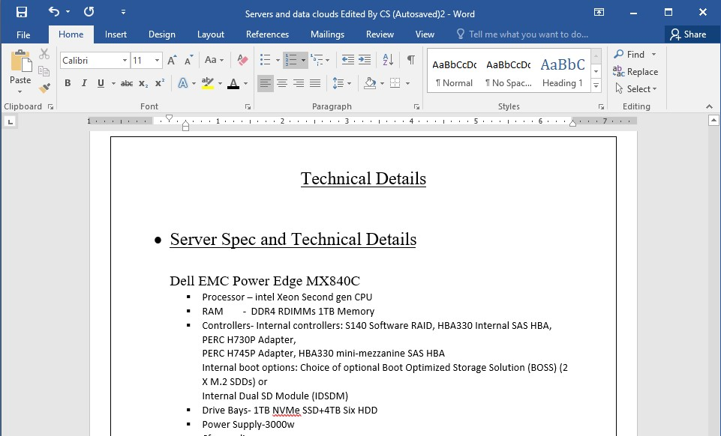

1. 27/04/2020 – we talked about the implementations of this part and it solutions.



1. Turntin report